AVERAGE RATE OF CHANGE
QUESTION STACK ACTIVITY

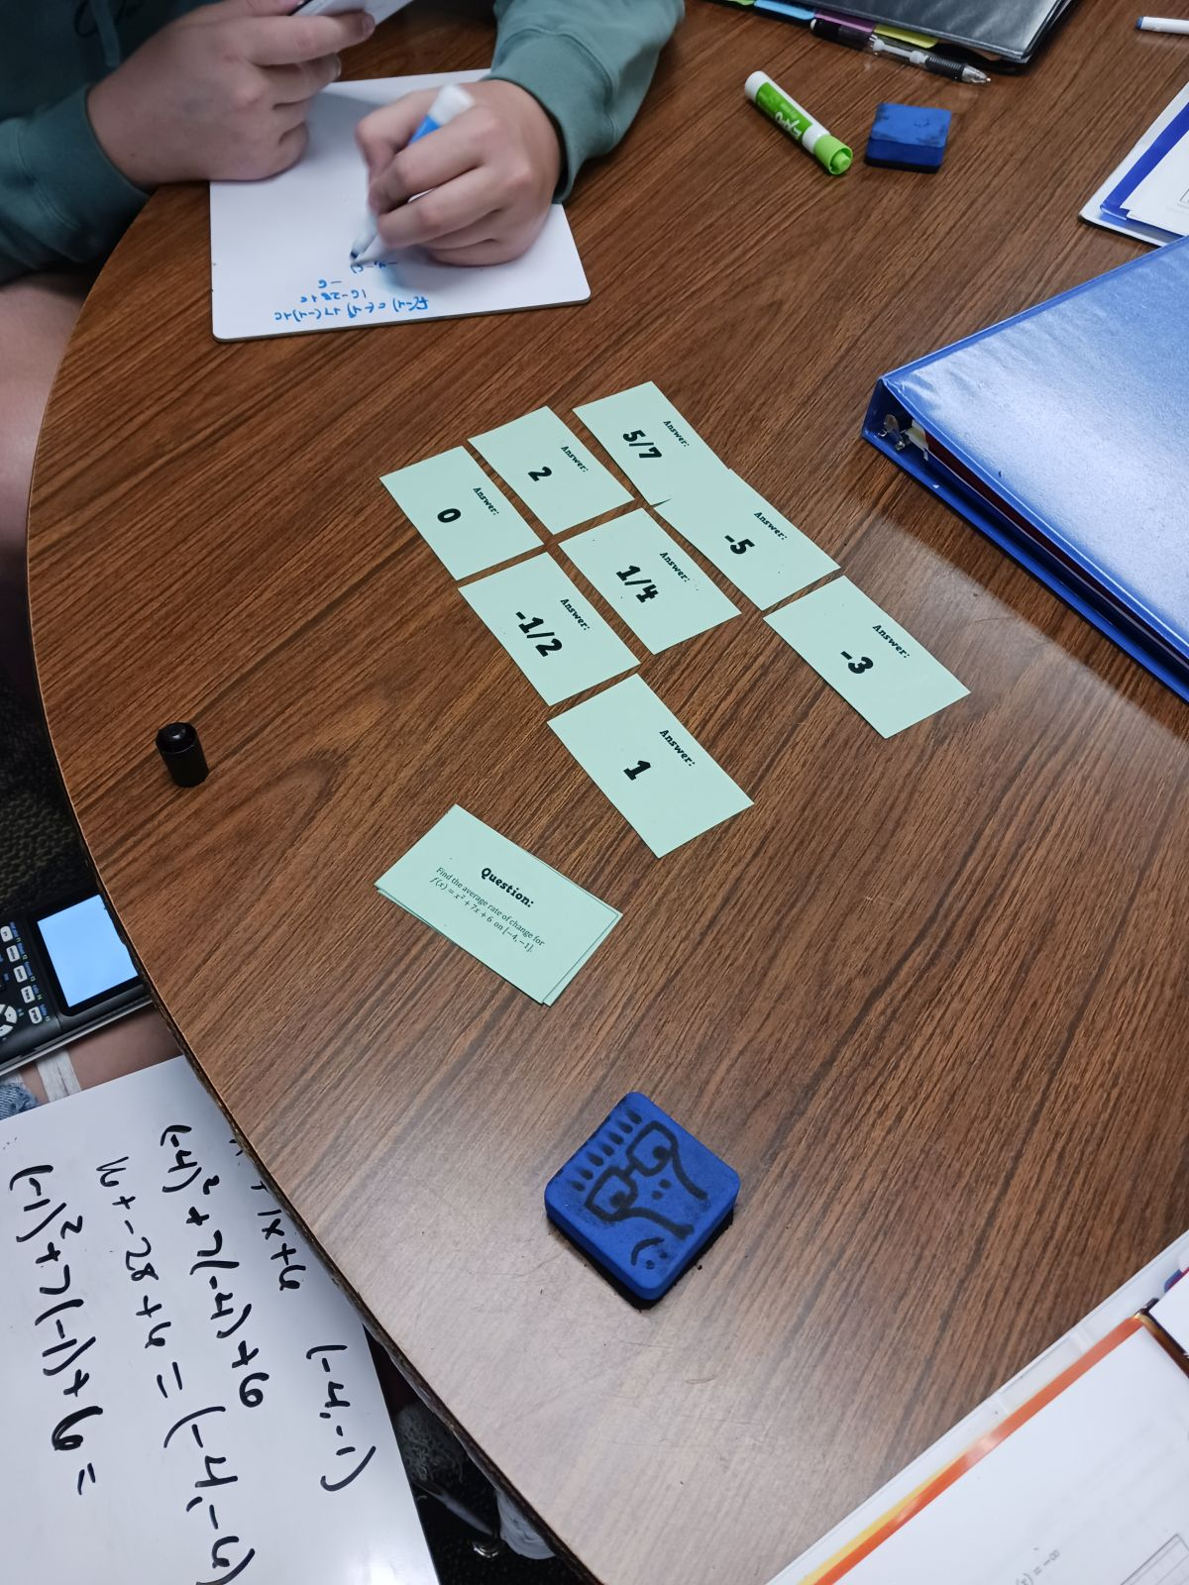

Activity Created by Sarah Carter | @mathequalslove | mathequalslove.net

QUESTION STACK INSTRUCTIONS
- Students lay out all of the question stack cards individually with the answer sides facing up. These cards form the "answer bank."
- Choose one card to flip over. I have them lay this card on top of their laminated question stack template (see below) so they don't get confused.
- Students work out the problem on the card they have just flipped over. When they have decided on an answer, they check the "answer bank" to see if their answer is there.
- If their answer is in the answer bank, they are (most likely) correct. If it isn't, they know that they have made a mistake. They need to check their work and/or ask for help.
- If the answer is in the answer bank, this card is flipped over to reveal a new question. This process repeats until the last question is flipped over.
- As students progress through the activity, the answer bank shrinks with each question solved. I find that my students' confidence grows as the answer bank shrinks.
- The question that ends up on the very top of the question stack will match the answer at the very bottom of the question stack.
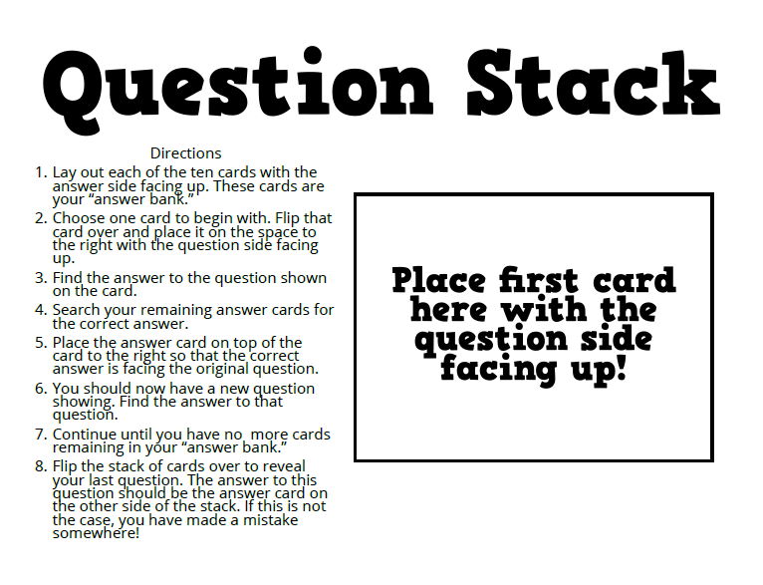
Download Copy of Question Stack Explanation Card for Students
Download Template to Create Your Own Question Stacks

Question:  $$Find the average rate of change for$$  $$h\left(x\right)=-x^{2}-8x+18 on \left[-8, 2\right].$$ | Question:  $$Find the average rate of change for$$  $$f\left(x\right)=x^{2}+7x+6 on \left[-4, -1\right].$$
Question:  $$Find the average rate of change for f\left(x\right) from$$  $$x=1 to x=8.$$  $$x$$ $$-3$$ $$1$$ $$4$$ $$8$$  $$f\left(x\right)$$ $$0$$ $$-2$$ $$7$$ $$3$$ | Question:  $Find the average rate of change for$ $p\left(x\right) on \left[6, 8\right].$  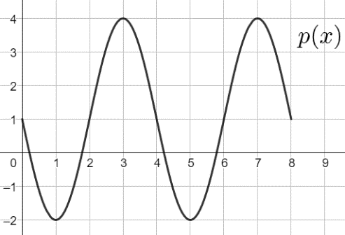
Question:  $$Find the average rate of change for$$  $$j\left(x\right)=-5x-7 on \left[-1, 1\right].$$ | Question:  $$Find the average rate of change for f\left(x\right) from$$  $$x=-3 to x=1.$$  $$x$$ $$-3$$ $$1$$ $$4$$ $$8$$  $$f\left(x\right)$$ $$0$$ $$-2$$ $$7$$ $$3$$
Question:  $Find the average rate of change for$ $p\left(x\right) on \left[3, 4\right].$ | Question:  $$Find the average rate of change for$$  $$g\left(x\right)=\sqrt{2x+3} on \left[3, 11\right].$$
Question:  $$Find the average rate of change for$$  $$g\left(x\right)=\frac{x-2}{x+4} on \left[-2, -1\right].$$ | Question:  $$Find the average rate of change for f\left(x\right) from$$  $$x=5 to x=10.$$  $$x$$ $$-2$$ $$1$$ $$5$$ $$10$$  $$f\left(x\right)$$ $$0$$ $$-2$$ $$8$$ $$5$$

Answer:  -2 | Answer:  -3/5
Answer:  5/7 | Answer:  2
Answer:  -5 | Answer:  0
Answer:  -3 | Answer:  -1/2
Answer:  1 | Answer:  1/4

