Question:  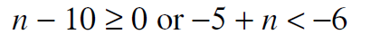 | Question:  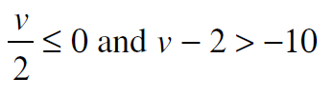
Question:  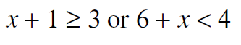 | Question:  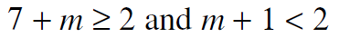
Question:  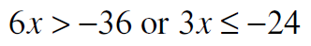 | Question:  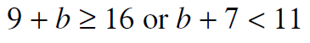
Question:  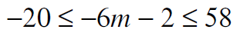 | Question:  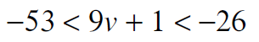
Question:  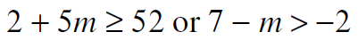 | Question:  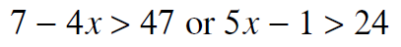
Answer:  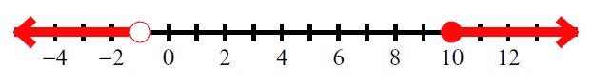 | Answer:  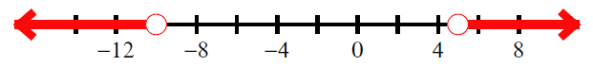
Answer:  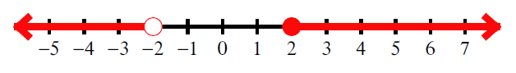 | Answer:  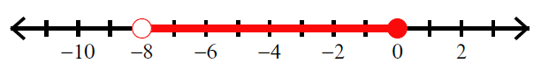
Answer:  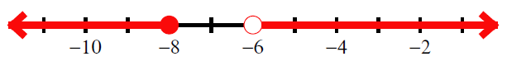 | Answer:  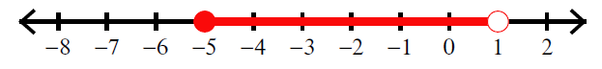
Answer:  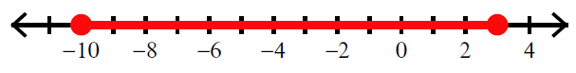 | Answer:  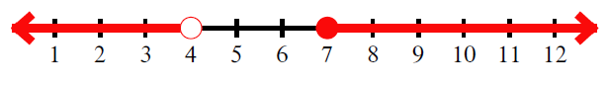
Answer:  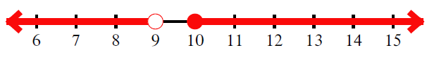 | Answer:  