2 TRUTHS AND A LIE A
$$f\left(x\right)=\frac{3x^{2}-9x+7}{2x-4x^{2}}$$ | $$g\left(x\right)=\frac{9x^{3}-2x+3}{x+2}$$ | $$h\left(x\right)=\frac{x^{4}\left(x-3\right)}{\left(x+2\right)\left(x-5\right)}$$

STATEMENTS
1. $f\left(x\right)$ has a slant asymptote.
2. $\lim_{x→∞}{g\left(x\right)= ∞}$
3. $h\left(x\right)$ does not have a horizontal asymptote.

WHICH STATEMENT IS THE LIE? EXPLAIN.
____________________________________________________________________________________________________________________________________________________________________________________________________________________________
2 TRUTHS AND A LIE B
$$f\left(x\right)=\frac{x^{4}+3}{x}$$ | $$g\left(x\right)=\frac{9-x^{2}}{x^{4}}$$ | $$h\left(x\right)=\frac{5x^{2}-3x+2}{x+7}$$ | $$j\left(x\right)=\frac{(x-2)(x+2)}{\left(2x-1\right)\left(2x+1\right)}$$

STATEMENTS
1. Two of the functions above have a horizontal asymptote.
2. Two of the functions above have a slant asymptote.
3. Two of the functions above have identical left and right end behavior.

WHICH STATEMENT IS THE LIE? EXPLAIN.
____________________________________________________________________________________________________________________________________________________________________________________________________________________________
MATCHING GRAPHS & EQUATIONS
CONNECT THE GRAPH OF EACH RATIONAL FUNCTION TO ITS EQUATION.
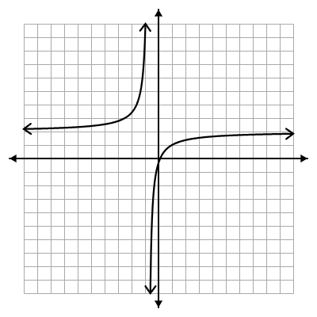  ● | 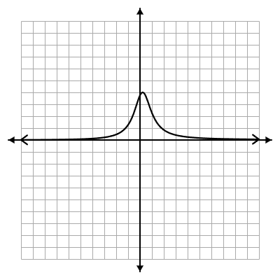  ● | 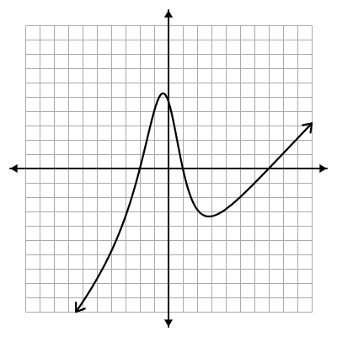  ●
●  $$f\left(x\right)=\frac{x+15}{5x^{2}-2x+4}$$ | ●  $$g\left(x\right)=\frac{8x-1}{4x+3}$$ | ●  $$h\left(x\right)=\frac{\left(x-1\right)\left(x+2\right)\left(x-7\right)}{x^{2}+3 }$$
CREATE A RATIONAL FUNCTION
$$\lim_{x→∞}{f(x)}=0$$  $$f\left(x\right)=$$ | Has a slant asymptote.  $$g\left(x\right)=$$
As the x values increase without bound, the y values decrease without bound.  $$h\left(x\right)=$$ | Horizontal asymptote of $y=5.$  $$j\left(x\right)=$$
COMPLETE THE LIMIT STATEMENTS
Determine which function must be written in the blanks of each pair of limit statements to create true statements regarding the end behavior.

$$f\left(x\right)=\frac{4x^{2}-2x+1}{x+3}$$ | $$g\left(x\right)=\frac{(2x-1)(2x+3)}{-(x-1)(x+1)}$$
$$h\left(x\right)=\frac{x}{x^{2}-1}$$ | $$j\left(x\right)=\frac{-9x^{5}-4}{-2x}$$
$$\lim_{x→-∞}{_____= -4}$$  $$\lim_{x→∞} _____{= -4}$$ | $$\lim_{x→-∞}{_____= -∞}$$  $$\lim_{x→∞} _____{= ∞}$$
$$\lim_{x→-∞}{_____= ∞}$$  $$\lim_{x→∞} _____{= ∞}$$ | $$\lim_{x→-∞}{_____= 0}$$  $$\lim_{x→∞} _____{= 0}$$

BUILDING RATIONAL FUNCTIONS
Arrange the expression pieces below (as numerators and denominators) to build functions with the following end behaviors. Each piece may only be used once.
$$\lim_{x→-∞}{f\left(x\right)=∞}$$  $$\lim_{x→∞}{f\left(x\right)=-∞}$$ | $$\lim_{x→-∞}{g\left(x\right)=4}$$  $$\lim_{x→∞}{g\left(x\right)=4}$$ | $$\lim_{x→-∞}{h\left(x\right)=0}$$  $$\lim_{x→∞}{h\left(x\right)=0}$$ | $$\lim_{x→-∞}{j\left(x\right)=-∞}$$  $$\lim_{x→∞}{j\left(x\right)=-∞}$$

$$f\left(x\right)=\frac{ }{ }$$ | $$g\left(x\right)=\frac{ }{ }$$
$$h\left(x\right)=\frac{ }{ }$$ | $$j\left(x\right)=\frac{ }{ }$$

$$2x^{2}$$ | $$-2x^{2}$$
$$8x$$ | $$-8x^{3}-2$$
$$-8x^{2}-2x-9$$ | $$8x^{4}$$
$$-(x+2)(x-2)$$ | $$18x^{5}-4$$
$$2x^{2}$$ | $$-2x^{2}$$
$$8x$$ | $$-8x^{3}-2$$
$$-8x^{2}-2x-9$$ | $$8x^{4}$$
$$-(x+2)(x-2)$$ | $$18x^{5}-4$$

