This is the back page.
It gets glued down to your comp book after you have filled out the rest of the sheet.

Cut out the top section- all the way to the fold.
Leave the middle sections.

Theorem 12-4-2

The composition of two _____________________________________ across two ______________________________________________ lines
is equivalent to a ____________________________________________.

- The translation vector is perpendicular to the lines.

- The length of the translation vector is twice the distance between the two lines.

Theorem 12-4-2

The composition of two _____________________________________ across two ______________________________________________ lines
is equivalent to a ____________________________________________.

- The center of rotation is the intersection of the lines.

- The angle of rotation is twice the measure of the angle formed by the lines.
Cut out the bottom section- all the way to the fold.
Across parallel lines

Across intersecting lines

Theorem 12-4-1
A composition of two isometries is an ___________________________________________________. Duh.

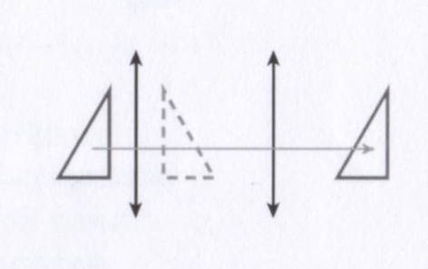

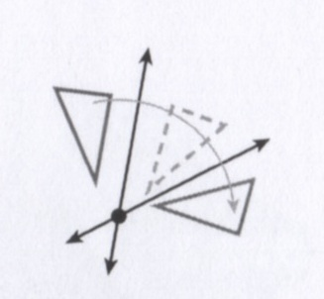

Theorem 12-4-3
Any translation or rotation is equivalent to two _________________________________________________________.

