Matador Dominoes Puzzle

Put the six pieces together in such a way that you get the seven double dominoes from double-blank to double-six.

Based on a Vintage German Puzzle Featured on http://www.robspuzzlepage.com/pattern.htm
Domino Clipart from ClipArt ETC (https://etc.usf.edu/clipart/)
Puzzle Typeset by Math = Love (https://mathequalslove.blogspot.com)
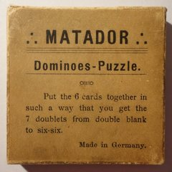
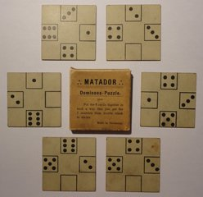
Image Source: http://www.robspuzzlepage.com/pattern.htm
 |  | 
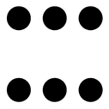 |  |  |  | 
 |  | 





Matador Dominoes – Smaller Version

