Matador Dominoes Puzzle

Put the six pieces together in such a way that you get the seven double dominoes from double-blank to double-six.

Based on a Vintage German Puzzle Featured on <http://www.robspuzzlepage.com/pattern.htm>

Domino Clipart from ClipArt ETC (<https://etc.usf.edu/clipart/>)

Puzzle Typeset by Math = Love (<https://mathequalslove.blogspot.com>)

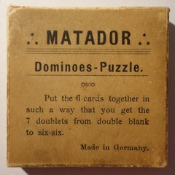

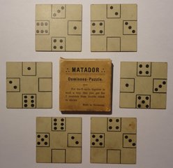

Image Source: <http://www.robspuzzlepage.com/pattern.htm>

|  |  |  |  |  |
| --- | --- | --- | --- | --- |
|  |  |  |  |  |
|  |  |  |  |  |
|  |  |  |  |  |
|  |  |  |  |  |
|  |  |  |  |  |

|  |  |  |  |  |
| --- | --- | --- | --- | --- |
|  |  |  |  |  |
|  |  |  |  |  |
|  |  |  |  |  |
|  |  |  |  |  |
|  |  |  |  |  |

|  |  |  |  |  |
| --- | --- | --- | --- | --- |
|  |  |  |  |  |
|  |  |  |  |  |
|  |  |  |  |  |
|  |  |  |  |  |
|  |  |  |  |  |

|  |  |  |  |  |
| --- | --- | --- | --- | --- |
|  |  |  |  |  |
|  |  |  |  |  |
|  |  |  |  |  |
|  |  |  |  |  |
|  |  |  |  |  |

|  |  |  |  |  |
| --- | --- | --- | --- | --- |
|  |  |  |  |  |
|  |  |  |  |  |
|  |  |  |  |  |
|  |  |  |  |  |
|  |  |  |  |  |

|  |  |  |  |  |
| --- | --- | --- | --- | --- |
|  |  |  |  |  |
|  |  |  |  |  |
|  |  |  |  |  |
|  |  |  |  |  |
|  |  |  |  |  |

Matador Dominoes – Smaller Version

