Skill | I can graph each of the six trig functions.

$$y=\sin\left(x\right)$$  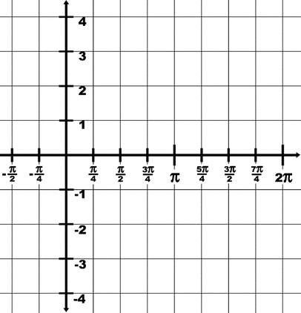 | $$y=\csc\left(x\right)$$
$$y=\cos\left(x\right)$$ | $$y=\sec\left(x\right)$$
$$y=\tan\left(x\right)$$ | $$y=\cot\left(x\right)$$

