Skill | I can find the distance between two points.

Pythagorean Theorem | Distance Formula

Example: Calculate the distance between (-4, 3) and (3, 5).
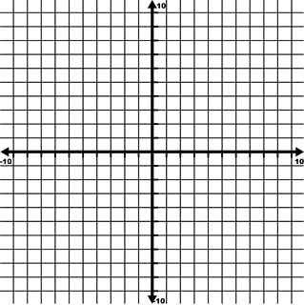
Example: Calculate the distance between (2, 10) and (-3, -2).
Classify the triangle ABC formed by the points A (0, -4), B (0, -9), and C (-2, -5).
Triangle ABC is a/an _____________________________________.

Classify the triangle DEF formed by the points D (-2, 4), E (8, 4), and F (6, -2).
Triangle DEF is a/an _____________________________________.

