PARTS OF A RIGHT TRIANGLE | PYTHAGOREAN THEOREM
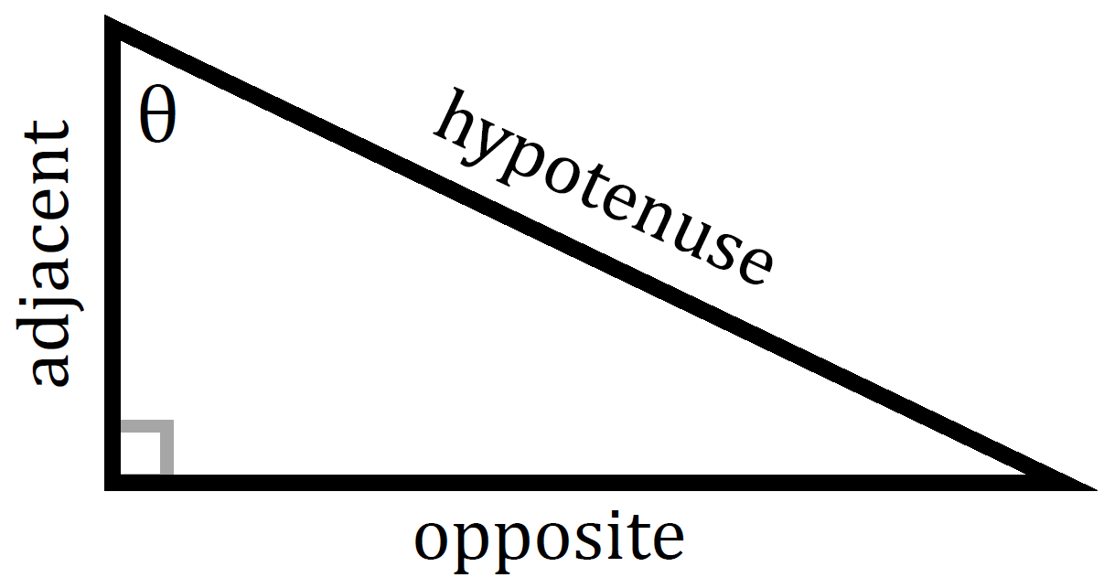 | $$a^{2}+b^{2}=c^{2}$$

SPECIAL RIGHT TRIANGLES
30° - 60° - 90° | 45° - 45° - 90°
1 - $\sqrt{3}$ - 2 | 1 – 1 - $\sqrt{2}$
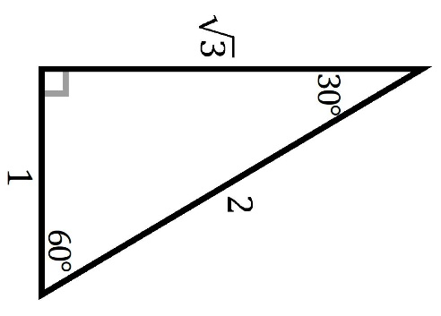 | 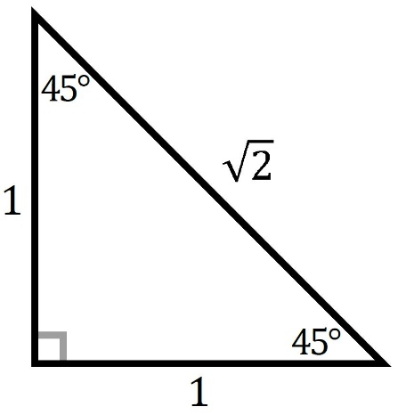

TRIG FUNCTIONS
SINE | COSINE | TANGENT
$$\sin\left(θ\right)=\frac{opp}{hyp}$$ | $$\cos\left(θ\right)=\frac{adj}{hyp}$$ | $$\tan\left(θ\right)=\frac{opp}{adj}$$

RECIPROCAL TRIG FUNCTIONS
COSECANT | SECANT | COTANGENT
$$\csc\left(θ\right)=\frac{hyp}{opp}$$ | $$\sec\left(θ\right)=\frac{hyp}{adj}$$ | $$\cot\left(θ\right)=\frac{adj}{opp}$$

