RT2 | I can find trigonometric functions of an angle, given a triangle.
Parts of a Right Triangle
opposite
adjacent
hypotenuse

θ

Basic Trig Functions
sine
cosine
tangent

SOH CAH TOA
Reciprocal Trig Functions
cosecant | reciprocal of
secant | reciprocal of
cotangent | reciprocal of
Find all six trigonometric functions of the angle, θ.
sin θ =
cos θ =
tan θ =
csc θ =
sec θ =
cot θ =
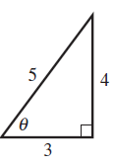

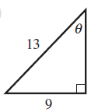
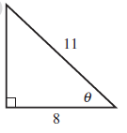
sin θ =
cos θ =
tan θ =
csc θ =
sec θ =
cot θ =

sin θ =
cos θ =
tan θ =
csc θ =
sec θ =
cot θ =

